La Rhétorique des Dieux

  - de Denis Gaultier

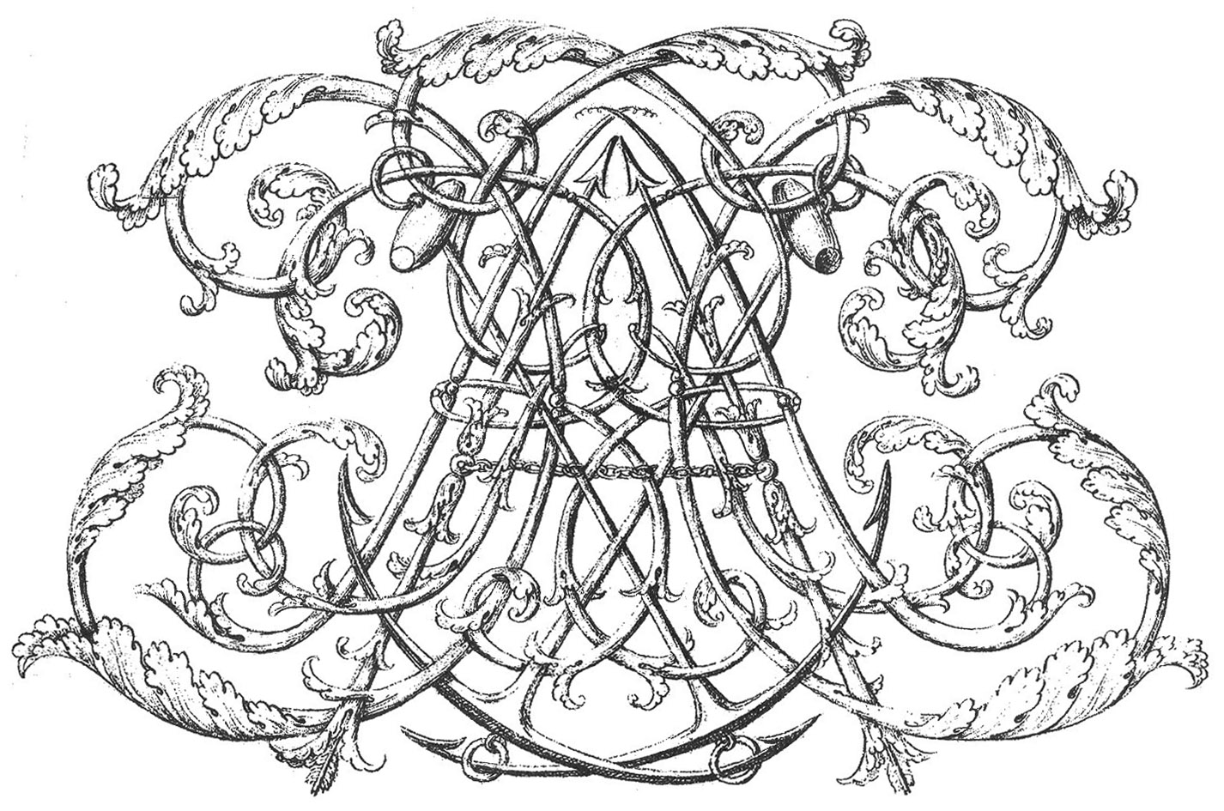

Civiol Richard

Created by Richard Civiol
Revised 2015 by Alain Veylit
Revised 2020 by David Smith

Editorial Notes

This edition is a revised version of the Richard Civiol edition that was revised by Alan Veylit in 2015. The tablature has been verified using the facsimile contained in La Rhetorique des Dieux by David J. Buch and La Rhetorique des Dieux facsimile by Atelier Philador. Corrections from David J. Buch’s La Rhetorique des Dieux were reviewed and generally used. The English translation comes from La Rhetorique des Dieux: A Critical Study of Text, Illustration, and Musical Style by David J. Buch and have been used with permission.
The detailed corrections to the manuscript are located at the end of the associated piece.
The title of the pieces has the format of the original French followed by the English translation in parenthesis and then the form of the piece in brackets. The form of the piece is from La Rhetorique des Dieux by David J. Buch.

FOR UNDERSTANDING THE BOOK
OF
THE RHETORIC OF THE GODS

Although the majority of those curious individuals wishing to understand this book have only to consult its contents with the eyes of the body and of the mind, nevertheless, to relieve those who do not wish to make the effort, they will know that the principal purpose of the person who wished to give it form has been to make a collection of the most beautiful lute pieces of the Illustrious Denis Gaultier. Those who know music well will find complete satisfaction in it in that this author expresses himself with so much art, so much skill, and in such choice terms, that of all of the parts of the body, he attracts the soul to the ear, and that he represents very perfectly the nature of the passions and raises the most depressed spirits to the most sublime virtues. This manner of expression may rightfully be called The Rhetoric of the Gods, inasmuch as human understanding is unable to conceive of a more eloquent language. As for the rest of what one sees in this book, they are decorations executed by the more famous artists of the century, of which a brief description follows.
By Master Baslin, Goldsmith, are
The ornaments on the cover of this book, consisting of two initials, framed by each one of the four parts of music, the caducei in the corners, and the lyres of Apollo, with which the book is closed.
By Master Ferrier
The inside corner engravings.
By Master Bosse
The first drawing, where one finds represented an altar upon which is placed a lute crowned with three wreaths, one of laurel, the next of myrtle, and the last of olive, with this verse above: Arbiter of Love, Peace, and War.

By Master Nanteuil, are
The portraits of Anne de Chambré and of damsel Genevieve Benoist, his wife.
By Master Eustache le Sueur is the drawing that follows, executed by Master Nantuil, in which are represented
Apollo in Heaven, holding his lyre, and Minerva presenting to him with her right hand, a portrait of damsel Anne de Chambré, on a sort of shield, supported by the love of virtue; and on the left arm of this goddess is a shield upon which Master Gaultier, the Illustrious, is represented.
By the same master, a drawing serving as the title and the beginning of this book, executed by Master Bosse, in which one finds represented
Three figures, in Heaven, under a zodiac: one representing Music, the other Harmony, and the last Eloquence. The first is holding an unrolled scroll upon which are inscribed the words The Rhetoric of the Gods, and near which is a mysterious prelude that has neither beginning nor end. The second figure, crowned as Queen of Heaven, holds a lute on which she plays this prelude. The third is crowned with pearls and diamonds. This arrangement announces that these divinities together make up the science of the great Gaultier.
All this is followed by twelve drawings by Master Bosse, executed by himself, that represent the twelve modes whose names are: Dorian or Doric, Hypodorian, Phrygian, Hypoprygian, Lydian, Hypolydian, Mixolydian, Hypomixolydian, Aolian, Hypoaolian Ionian, and Hypionian. As each of these modes has the property of exciting certain passions and is appropriate to certain melodies, the artist has represented in each drawing the actions that the mode incites, the most suitable ancient and modern instruments, and he has even taken care to include the architecture conforming to these modes. In each of these drawings is above all a lute, with an open book in which the mode is notated.
The explanation of the pieces that follow these modes will be incomparably better understood by the pieces themselves than by the little discourse that is found beneath each piece, which is solely for the understanding of those who do not have a complete knowledge of music.
By the same Bosse, is
At the end of the book, a little Mars holding a sword in one hand and a writing pen in the other, seated on a carpet where the coat of arms of Master de Chambré is laid out in perspective.
By Master Belluchau are
The drawing of the initials, and the writings that are below each piece.
By Master Damoiselet is
This writing and the table of contents found at the end of the book.

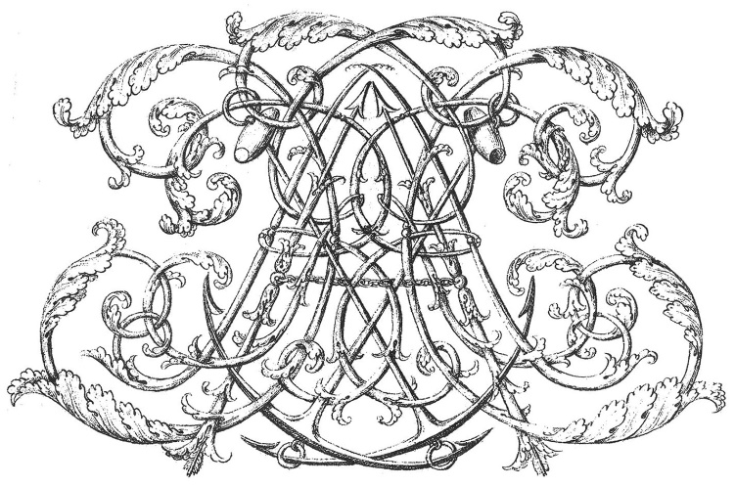

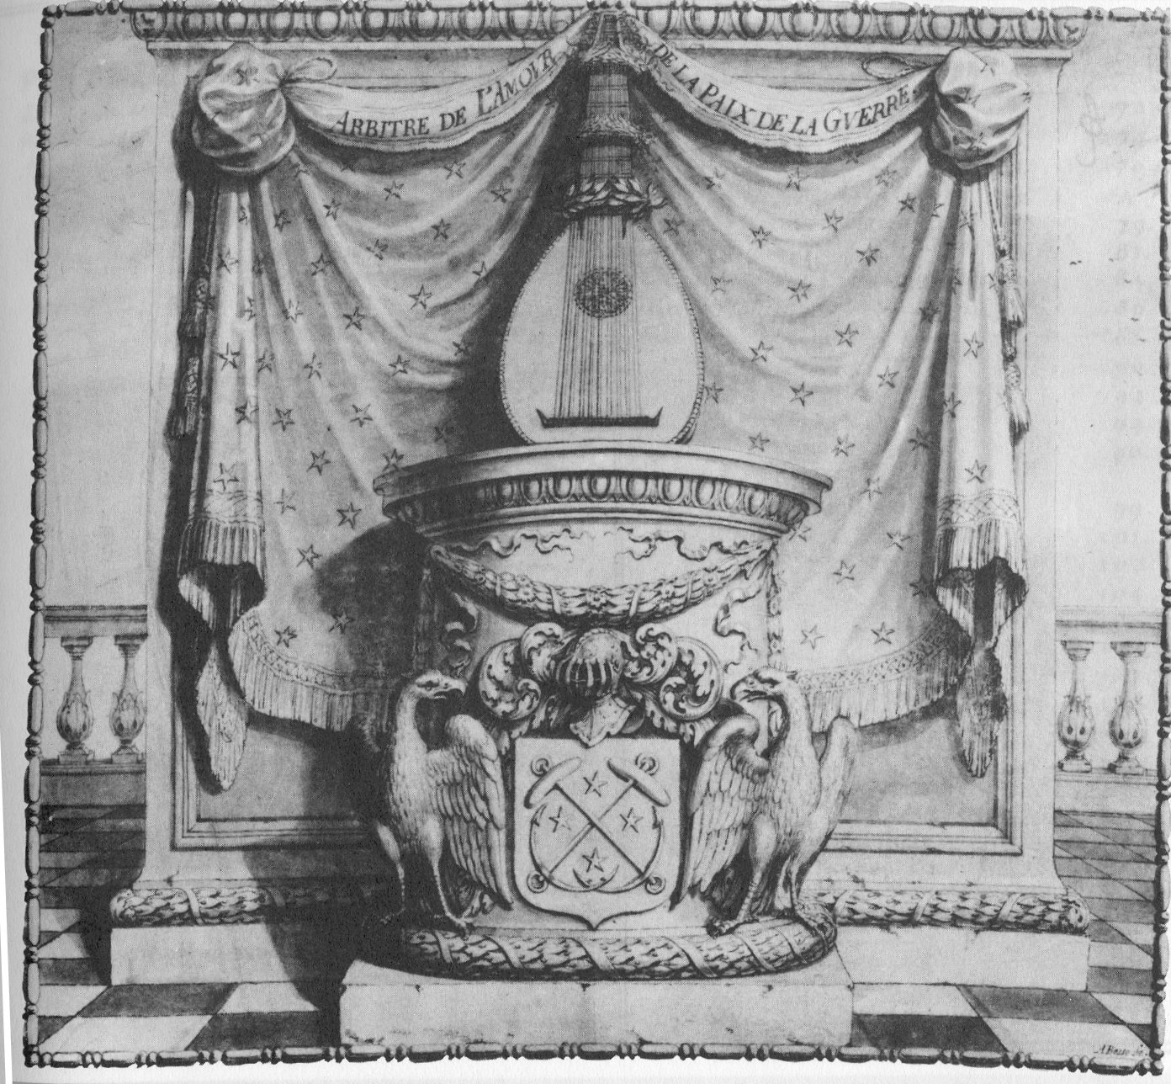

Table of Contents
Editorial Notes | i
For Understanding the Book of the Rhetoric of the Gods | ii
The Lute Triumpant | v
Table of Contents | vi
Apollo in the Sky and Portraits | x
Sonnet of Harault | xi
Sonnet of Gauquelin | xii
Book Title with Prelude | xiii
Prelude | xiv
I. Mode Dorien | 1
1. Mode Dorien Accord (D Major) | 2
2. La Dedicasse (The Dedication) [Pavanne] | 3
3. Phaëton foudroyé (Phaëthon Struck Down) [Allemande] | 4
4. Le Panegirique (The Panegyric) [Allemande or Gigue] | 5
5. Minerve (Minerva) [Courante] | 6
6. Ulisse (Ulysses) [Courante] | 7
7. [Double to the Courante] | 8
8. [Sarabande] | 9
II Sous Dorien | 10
9. Sous Dorien Accord (A Major) | 11
10. [Prelude] | 12
11. Andromede (Andromeda) [Allemande or Gigue] | 13
12. Diane (Diana) [Courante] | 14
13. La Coquette Virtuosa (The Virtuous Coquette) [Courante] | 15
14. [Allemande or Gigue] | 16
15. Atalante (Atalanta) [Allemande or Gigue] | 17
16. [Sarabande] | 18
III Mode Phrygien | 19
17. Mode Phrygien Accord (F# Minor) | 20
18. Tombeau de Madamoiselle Gaultier [Allemande or Gigue] | 21
19. [Sarabande en rondeau] | 22
20. Mars superbe (Mars superb) [Galliarde] | 23
21. Cleopatre amante (Cleopatra the Lover) [Courante and Double] | 24
22. [Double to Courante] | 25
23. [Sarabande] | 26
IV Sous Prhygien | 27
24. Sous Phrygien Accord (F# Minor) | 28
25. Artemise ou l'Oraisõ funebre (Artemisia or the Funeral Oration) [Courante] | 29
26. Le Triomphe (The Triumph) [Courante] | 30
27. [Courante] | 31
28. [Allemande or Gigue] | 32
29. [Allemande or Gigue] | 33
V Mode Lydien | 34
30. Mode Lydien Accord (E Minor) | 35
VI Souslidien | 36
31. Souslidien Accord (G Major) | 37
32. [Gigue] | 38
33. [Courante] | 38
34. [Double to the Courante] | 40
35. [Courante] | 41
36. [Double] | 42
37. [Courante] | 43
38. [Double to the Courante] | 44
39. [Sarabande] | 45
VII Myxolydien | 46
40. Mode Myxolydien Accord (F Major) | 47
41. Appolon Orateur(Apollo the Orator) [Allemande or Gigue] | 48
42. [Courante] | 49
43. [Courante] | 50
44. [Double to the Courante] | 51
45. Diane au bois(Diana in the Woods) [Sarabande] | 52
VIII Sous Myxolydien
46. Sous Myxolydien Accord (F Major) | 53
47. [Allemande or Gigue] | 54
48. La Caressante (The Tender Lady) [Courante] | 55
49. [Canarie] | 56
IX Mode Aeolien | 57
50. Mode Aeolien Accord (G Minor) | 58
51. Circé (Circe) [Pavanne] | 59
52. Cephale (Cephalus) [Courante] | 60
53. [Sarabande] | 61
X Sous Aeolien | 62
54. Sous Aeolien Accord (G Minor) | 63
55. l'Héroique (The Heroic Man) [Allemande] | 64
56. [Courante] | 65
XI Mode Ionien | 66
57. Mode Ionien Accord (A Minor) | 67
58. [Prelude] | 68
59. Orphée (Orpheus) [Allemande or Gigue] | 69
60. Echo [Allemande or Gigue] | 70
61. [Courante] | 71
62. l'Homicide (The Murderess) [Courante] | 72
63. [Sarabande] | 73
64. La Gaillarde (The Saucy Lass) [Galliarde] | 74
65. [Courante] | 75
66. [Double to the Courante] | 76
XII Sous Ionien | 77
67. Sous Ionien Accord (A Minor) | 78
68. [Pavanne] | 79
69. La Pastoralle (The Pastoral) [Allemande or Gigue] | 80
70. Narcisse (Narcissus) | 81
71. Junon ou la Jalouse (Juno, or Jealousy) [Courante] | 82
72. [Sarabande] | 83
73. Tombeau de Mons.r. de Lenclos (Tombeau of Mr de Lenclos) [Allemande] | 84
74. La consolation aux amis du Sr Lenclos (The consolation to the Friends of Sr Lenclos) [Courante] | 85
75. La Resolution des amis du Sr Lenclos sur sa mort (The Resolution of the Friends of Sr Lenclos upon his Death) [Sarabande] | 86
Mars on the Arms of Sr de Chambré | 87

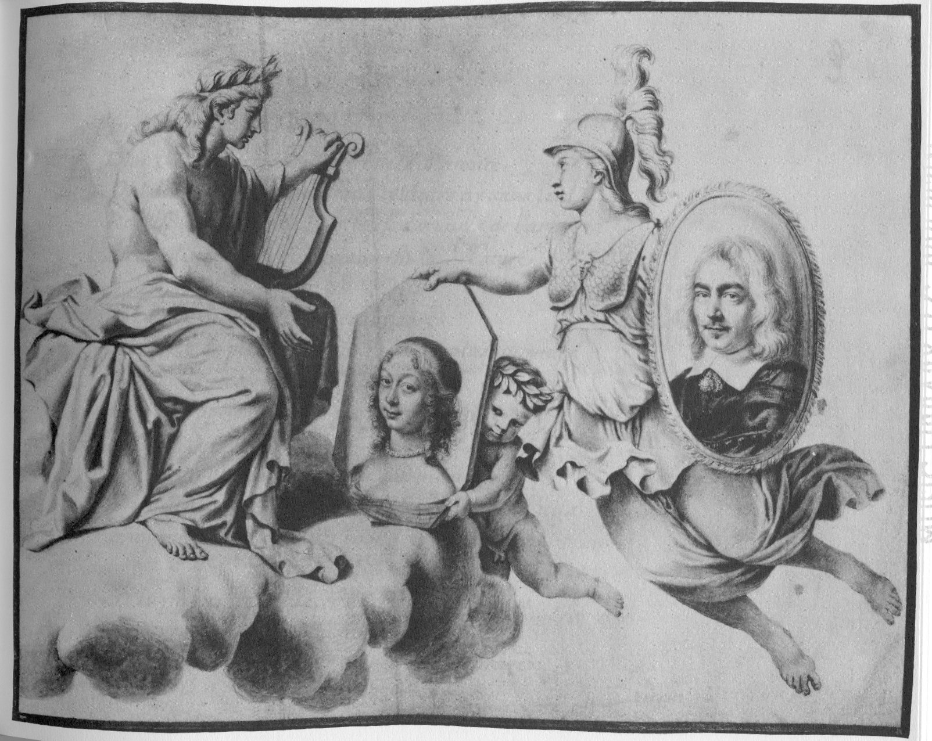
SONNET

Admire in these portraits the effect of depiction,
Which with a mere pencil, without color or make-up,
Represents to our eyes these masterpieces of art,
Accomplished in every way as nature does.

Admire the relief of this cover;
Is there anything more beautiful, rich or graceful
The Gods each took part in this work,
When Apollo wished to create his tablature.

But since then, attracted by the harmonious air
Of the Lute of this Nymph, he descended from the heavens,
Borrowing the apparel and face of Gaultier.

He shows here how to pluck in a hundred beautiful ways;
An in order to immortalize his divine lessons,
He dedicates in Gaultier’s honor this precious book.
Harualt

SONNET
to the book

Unequaled work of admirable structure,
You appear to our eyes an enchanted volume,
Because the Liberal Arts did not give birth to you,
Since we have nothing equal to you in nature.

How many learned concerts of erudite tablature,
Never has anyone invented a better plan;
One can see nothing better represented;
Your Chinese ink effaces representation.

Mankind has not been able to produce a work so perfect;
It is Phoebus, who fatigued from his effort,
Goes off to rest on the breast of Urania.

He has nevertheless sought out twelve modes in vain;
All that is needed to unite the entire Symphony,
Is the Ilustrious Gaultier and his lute in hand.
Gauquelin

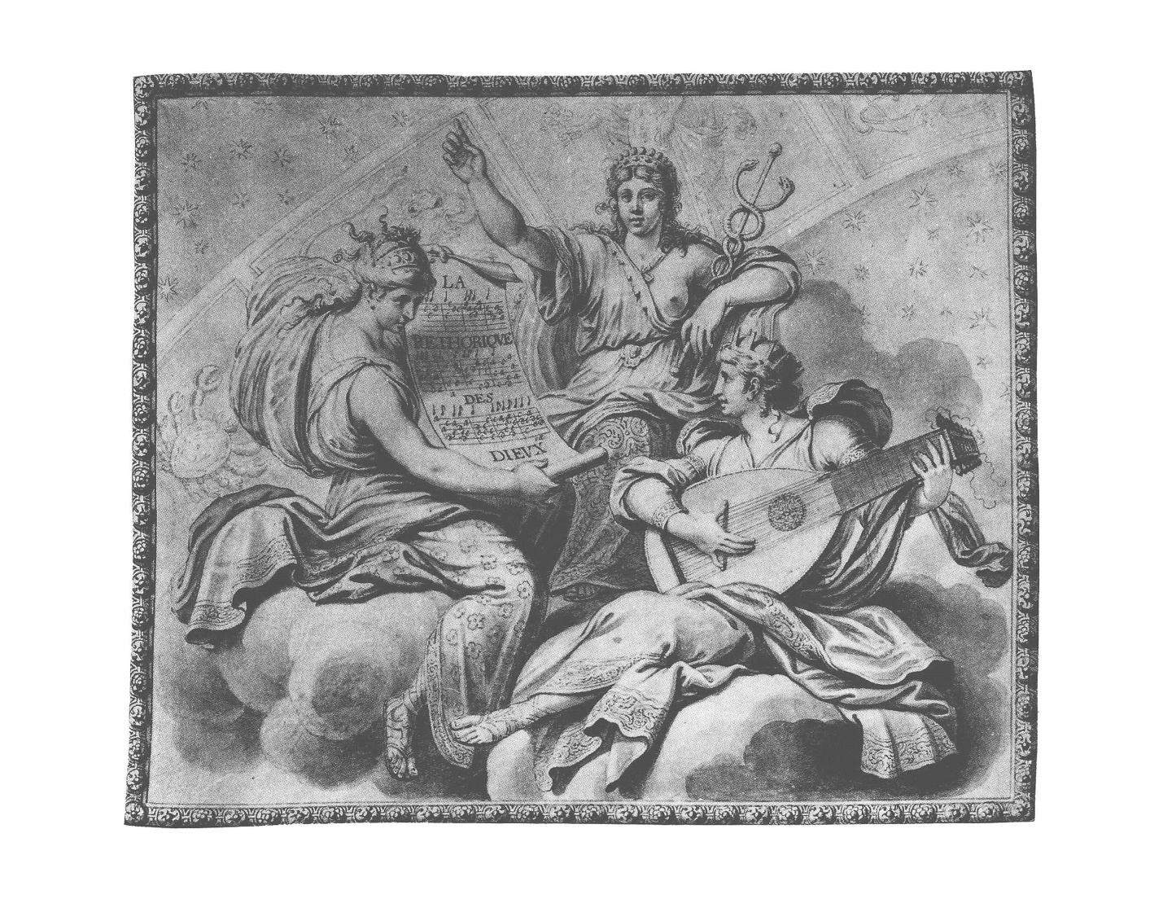

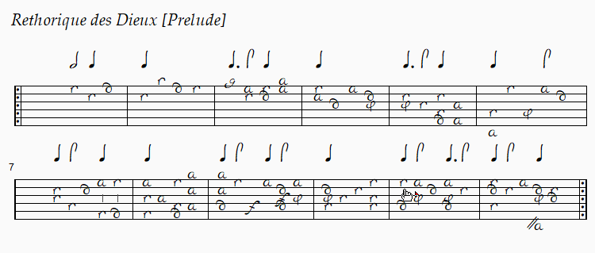

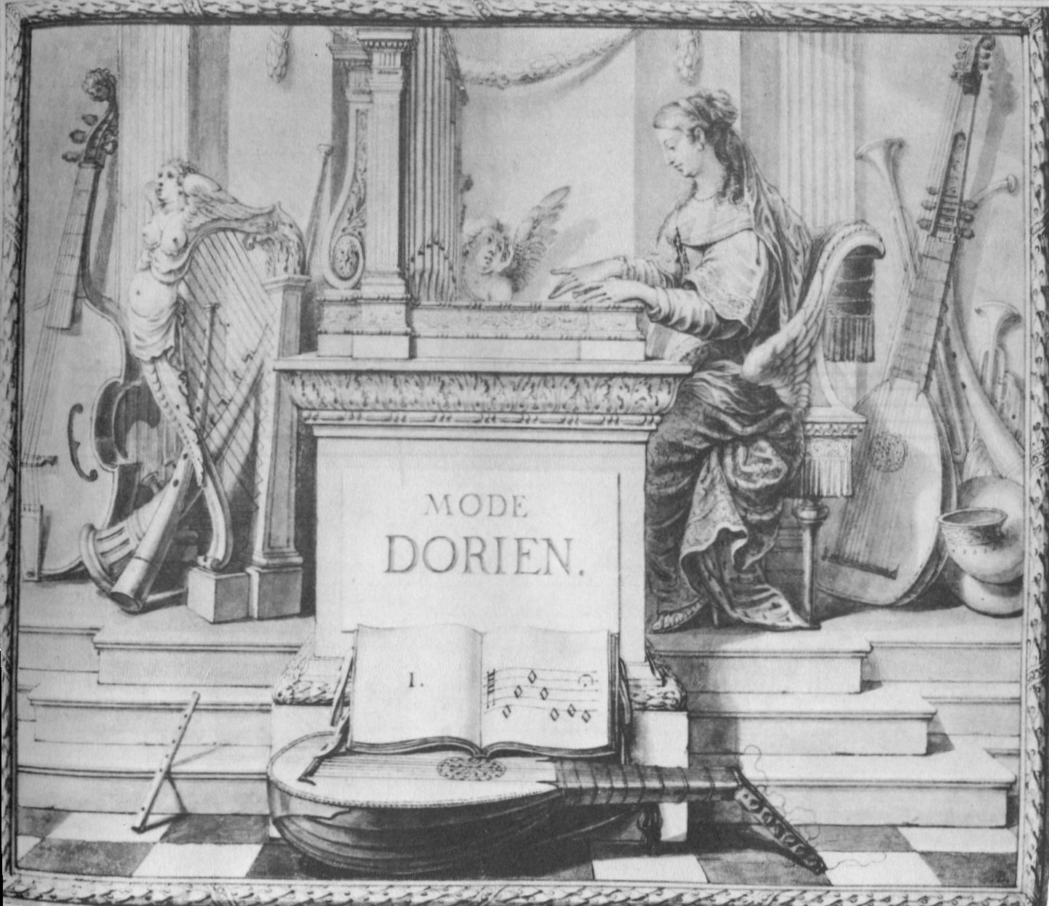

Gaultier, Denis. “A Facsimile of Berline, Staatliche Museen Preuẞischer Kulturbesitz, Kupferstichkabenett, MS. 78 C12.“ La Rhetorique des Dieux, edited by David J. Buch, A-E Editions, Inc., 1990.
Gaulter, Denis. La Rhetorique des Dieux, ATELIER PHILIDOR, 2020.
Buch, David Joseph. La Rhétorique des Dieux: A Critical Study of Text, Illustration, and Musical Style, PhD Thesis Northwestern University, 1983 pp. 60-76.
Gaultier, Denis. “A Facsimile of Berline, Staatliche Museen Preuẞischer Kulturbesitz, Kupferstichkabenett, MS. 78 C12.“ La Rhetorique des Dieux, edited by David J. Buch, A-E Editions, Inc., 1990, table of contents.

